Design and Analysis of Algorithms (CS206)

Practical Exam

**U19CS012**

1. Sapna is an instructor. She needs to give a few confections to her students.

Every student sits in a line and every one of them has a rating score as per

their performance.

**CONTRAINTS:**

Sapna needs to give **at least 1 candy** to every student.

Assuming two kids sit close to one another, the **one with the higher rating**

**should get more confections**.

Sapna needs to limit the complete number of confections she should purchase.

**Example:**

She gives the students confections in the following minimal amounts: [1,2,1,2,3,1]. She must buy a minimum of 10 candies.

**Returns**

int: the **minimum** number of confections sapna must buy

**Input:**

The first line contains an integer, **n**, the size of arr.

Each of the next n lines contains an integer arr[i] indicating the rating of the

student at position i.

**Output:**

Minimber number of confections n.

Key Observations:

1.) Sorting Approach Won’t Work! [Change the Arrangement]

2.) Finding the Highest and Lowest Won’t Work!

**Pseudo Code:**

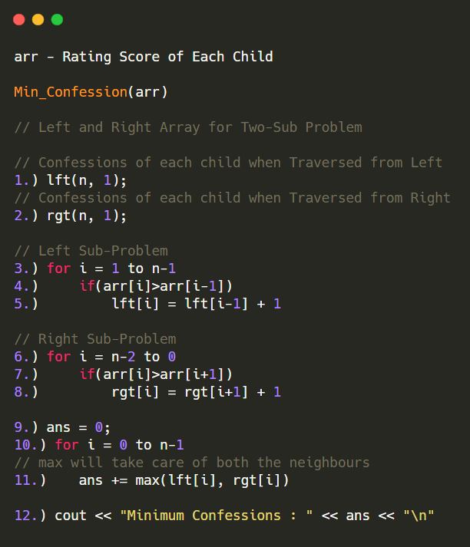

**Code:**

*// U19CS012 BHAGYA VINOD RANA*

*#include* <bits/stdc++.h>

using namespace std;

typedef long long int ll;

int main()

{

*// Input*

    ll n;

    cin >> n;

    vector<ll> arr(n, 0);

*for* (auto &x : arr)

    {

        cin >> x;

    }

*// Confessions of each child when Traversed from Left*

    vector<ll> lft(n, 1);

*// Confessions of each child when Traversed from Right*

    vector<ll> rgt(n, 1);

*// Left Sub-Problem*

*for* (int i = 1; i < n; i++)

    {

*if*(arr[i]>arr[i-1])

            lft[i] = lft[i-1] + 1;

    }

*// Right Sub-Problem*

*for* (int i = n-2; i >=0; i--)

    {

*if*(arr[i]>arr[i+1])

            rgt[i] = rgt[i+1] + 1;

    }

    ll ans = 0;

*for* (int i = 0; i < n; i++)

    {

*// max will take care of both the neighbours*

        ans += max(lft[i], rgt[i]);

    }

    cout << "Minimum Confessions : " << ans << "\n";

*return* 0;

}

Time Complexity = **O(n)**

**Test Cases:**

1) [11, 4, 3, 11, 33, 33, 1, 67]

Left: [1, 1, 1, 2, 3, 1, 1, 2]

Right: [3, 2, 1, 1, 1, 2, 1, 1]

Answer: [3, 2, 1, 2, 3, 2, 1, 2]

Minimum Confessions: 16

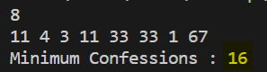

2) [1, 2, 1, 2, 3, 1] <Sample Test Case>

Left: [1, 2, 1, 2, 3, 1]

Right: [1, 2, 1, 1, 2, 1]

Answer: [1, 2, 1, 2, 3, 1]

Minimum Confessions: 10

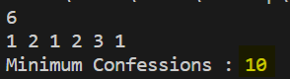

3) [100] <Trivial Case>

Minimum Confessions: 1

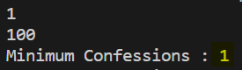

**SUBMITTED BY:**

**U19CS012**

**BHAGYA VINOD RANA**